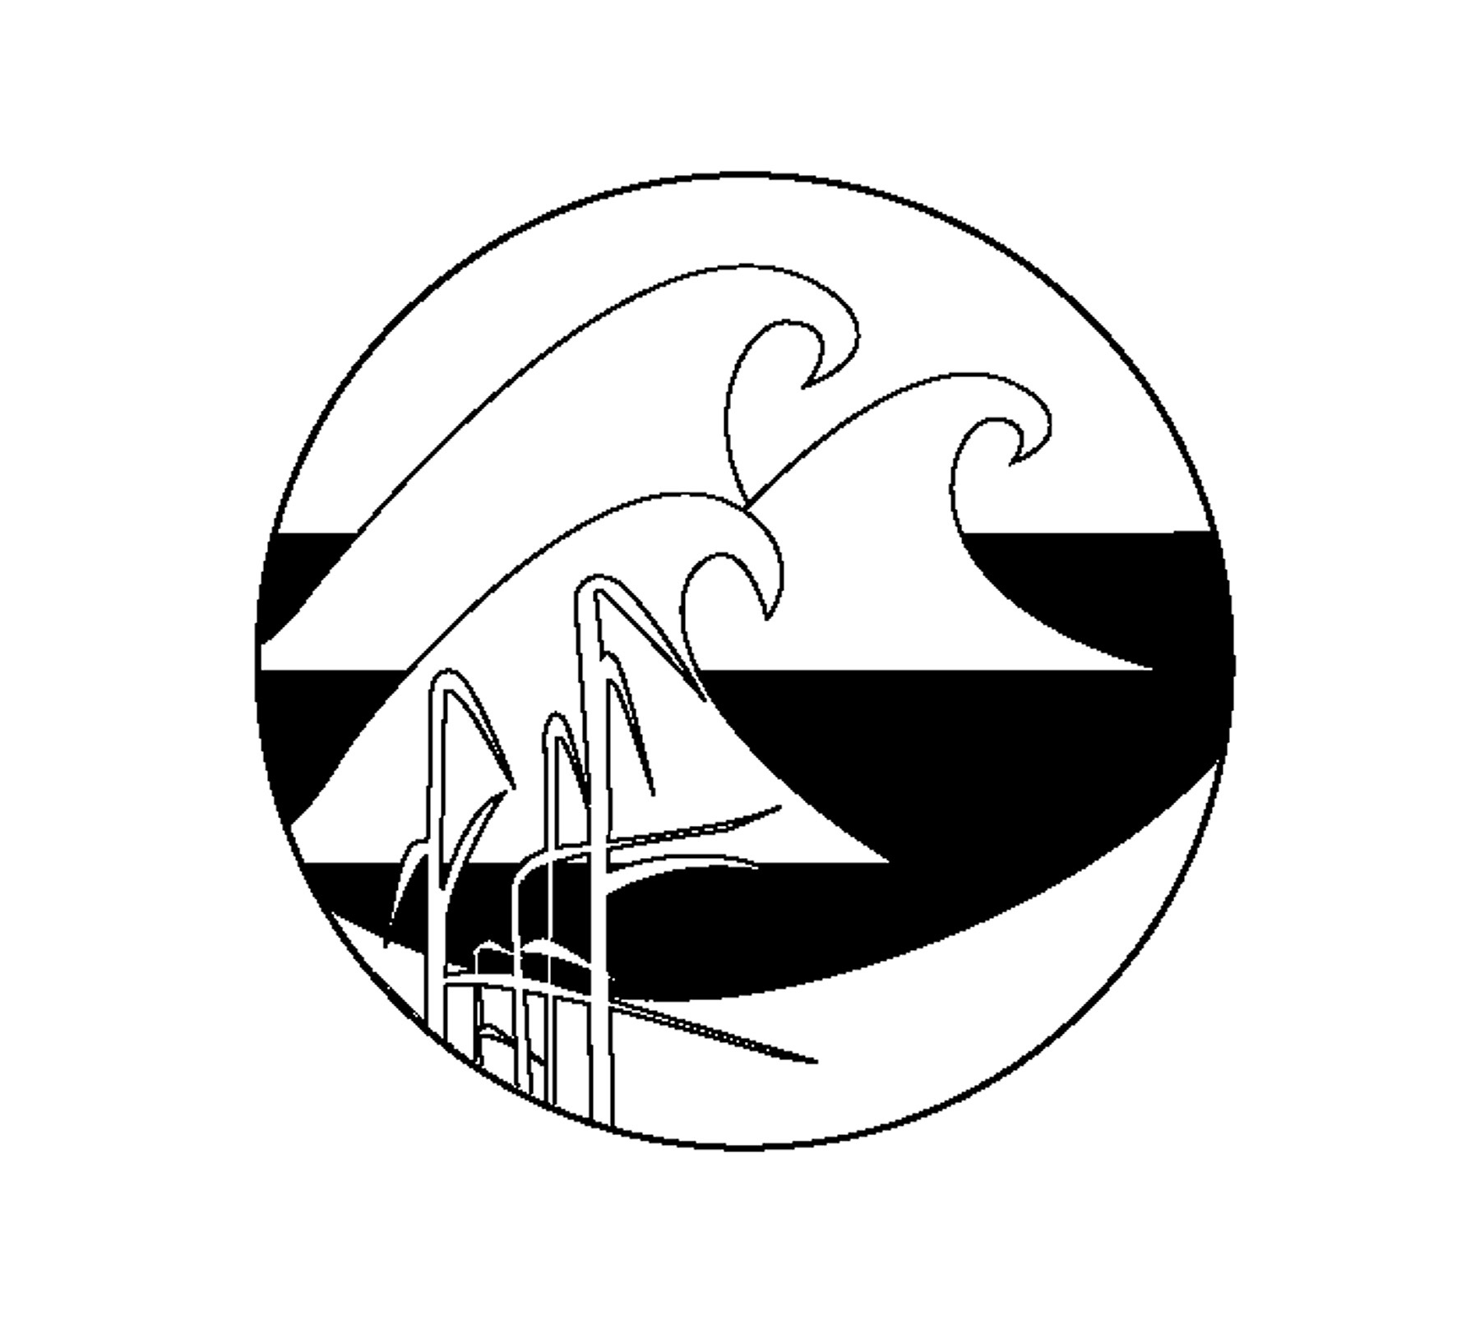
PROJECT OCEANOLOGY
Physical Oceanogr

Data Table: How has LIS changed over time?
Physical Factors | Pattern (increase, decrease, no change)
Temperature
Salinity
Dissolved Oxygen (Bottom)
pH

Organisms | Pattern (increase, decrease, no change)
Spider Crabs
Lobsters
Porgy/Scup
Summer Flounder
Winter Flounder
Windowpane Flounder

Discussion Questions

Consider your class dataset as a whole as you answer the following questions:
- How has the physical environment of Long Island Sound changed over time?
- What do you think caused these physical changes?
- How has the biological community living in Long Island Sound changed over time?
- What do you think caused these biological changes?
- List some ways that physical changes to an environment can affect the organisms that live there:
- List some ways that a change in abundance of one organism might affect the abundance of another organism:
- Imagine that twenty years from now, you return to Project Oceanology and sample again. What changes would you expect to see?

